ST. XAVIER’S COLLEGE

**(Affiliated to Tribhuvan University)**

Maitighar, Kathmandu



**Computer Graphics Lab Assignment #2**

**To Make a Simple Calculator**

**Submitted by:**

Bikash Paneru

013BSCCSIT012

**Submitted to:**

|  |  |
| --- | --- |
| Er. Anil K. Sah  Lecturer, St. Xavier’s College |  |

**STATEMENT:**

To Make a Simple Calculator

**SOURCE CODE:**

using System;

using System.Collections.Generic;

using System.ComponentModel;

using System.Data;

using System.Drawing;

using System.Linq;

using System.Text;

using System.Threading.Tasks;

using System.Windows.Forms;

namespace Calculator

{

public partial class Form1 : Form

{

public Form1()

{

InitializeComponent();

}

float previousNumber; //Stores the number input before pressing the operation buttons

String operation; //Stores the operation to be done

Boolean firstEntered; //Stores if the first digit has been input

private void numericPressed(object sender, EventArgs e)

{

//Make the display show the current number

//Concatenate if needed

if (firstEntered)

{

outputDisplay.Text += ((Button)sender).Text;

} else

{

outputDisplay.Text = ((Button)sender).Text;

firstEntered = true;

}

}

private void operationPressed(object sender, EventArgs e)

{

//Get the type of operation to be done and store in operation

operation = ((Button)sender).Text;

//Store the current number input

previousNumber = getFloatFromDisplay();

firstEntered = false; //The first digit of the second number has to be input

}

private void equalsPressed(object sender, EventArgs e)

{

//Do only if something has been entered

if (outputDisplay.Text != String.Empty)

{

//Get the current number input

float currentNumber = getFloatFromDisplay();

float output; //Stores the output

//Perform the operation according to the previously set operation

switch (operation)

{

case "+":

output = previousNumber + currentNumber;

break;

case "-":

output = previousNumber - currentNumber;

break;

case "/":

output = previousNumber / currentNumber;

break;

case "X":

output = previousNumber * currentNumber;

break;

default:

output = currentNumber;

break;

}

//Set content of display to the result obtained (value of output)

outputDisplay.Text = output.ToString();

//Clear the operation

operation = String.Empty;

firstEntered = false; //The first digit of the new number has not been input

}

}

private float getFloatFromDisplay()

{

try {

return float.Parse(outputDisplay.Text);

} catch (Exception ex)

{

return 0;

}

}

private void allClearPressed(object sender, EventArgs e)

{

operation = String.Empty;

previousNumber = 0;

firstEntered = false;

outputDisplay.Text = "0";

}

private void clearPressed(object sender, EventArgs e)

{

firstEntered = false;

outputDisplay.Text = String.Empty;

}

}

}

**OUTPUT:**

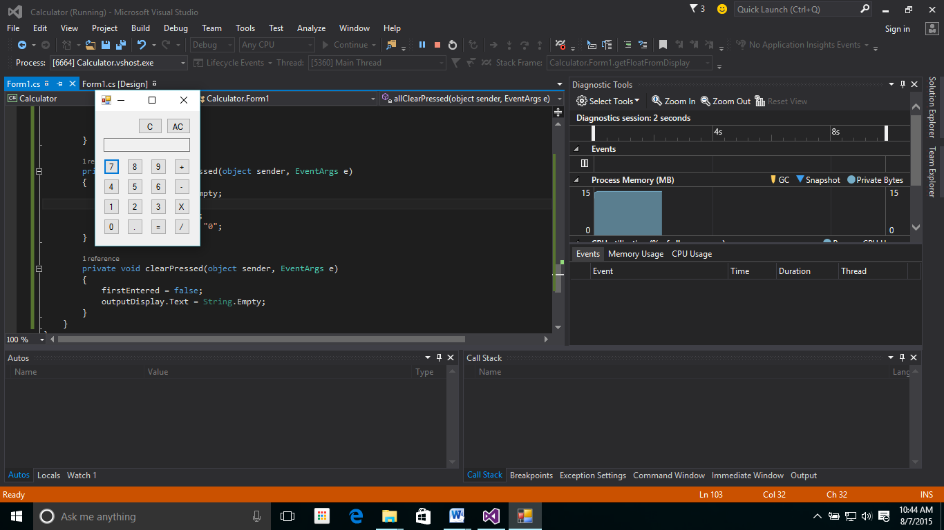

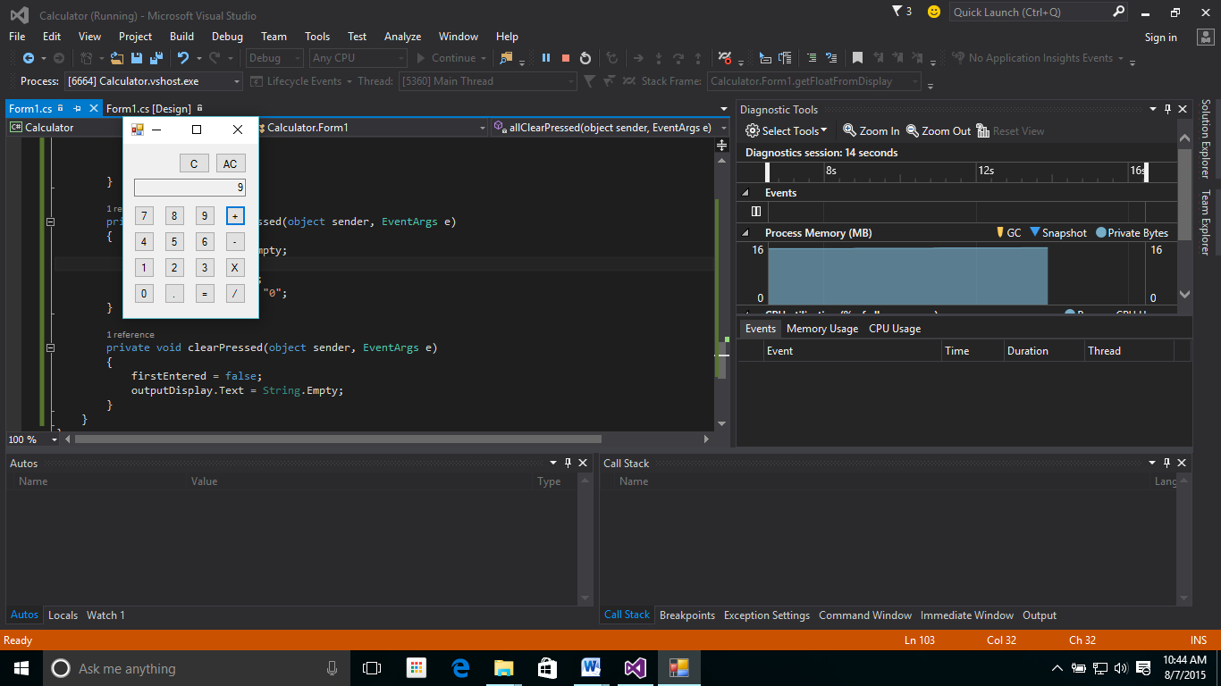

**CONCLUSION:**

Thus, a simple calculator was created in Visual Studio 2015 by using the C# Windows Forms API.